lH[ .M!EA3C KG 417/KQA.040.RU.02.00120
CepJUI KG 0097813
OPf AH no CEPTH<l>HKAUHH 06UleCTBa c orpaHH'iCHHOH OTBeTCTBCHHOCTblO «flpoMMaum.
MecTO HaxoJKlleHm1: 720040, Kb1prbl3CKaJ1 Pecny6nuKa , ropo.n Ei11wKe1<, ynuua Pa33aKoea, JJ.OM 32, JTaJK 6. Te.11e¢0H : +996 553 232 235. Aitpec 3neKTpOHHOH nottTb1: info@prom-mash.com.
ArrecTaT aKKpeimTamm perncrpauHoHHblH N2 KG 417/KUA.OCTI.040, Bbl.ll.aH 07.12.2021 roJJ.a.

3AHBHTEJib OlilECTBO c orPAHl14EHHOl1 OTBETCTBEH HOCTblO "}J.HAJIAt'rT rrYnn"
MeCTo ttaxoJKllemu1 : 115432, PoccW!, ropo.n MocKBa, yn11ua TpoqrnMoea, ZlOM 32, KOpnyc I , n0Meutem1e l, :na)K I, KOMHaTht 23,25
Anpec Mecrn ocymecTenettH11 .ne11TenbHOCTH; 143532, Poccm1, MocxoecKaJI o6nacTb, 11CTpHllCKIH paiion, ropo.n }J.e.noecK, BonoKonaMCKa11 I -JI yn11ua, noM 60.
0CHOBHOH rocynapCTBeHHblH perHCTP3UHOHHblH HOMep 1 145024006600.
Tenecpott : 8(495) 133-10-51, A.a.pee :meKTPOHHOH nottTbJ :info@dialuch.ru.
H3f OTOBUTEJIJ. OEiIJ.tECTBO COfPAHl1lJEHHOM OTBETCTBEHHOCTblO ")l11AJIOO fPYflfl"
MeeTO 1taxoJKllet1W1: 115432, PoccHJI, ropon MocKBa, ymma TpoqrnMoea, JJ.Ol\:I 32, Kopnyc J, noMeiueme I, JT3)1( I , KOMHaThl 23,25 Anpec MCCTa ocymecTBJICHHJI .ACllTeJlbHOCTH no H3rOTOBfl CHJ110 npOAYKL\ 111'!: 143532,Pocc1rn, MOCKOBCKaJI o6nacn., 11CTPHHCKHH pai1011, ropo.n }J.e.o.oecK, BonoKonaMCKaJI l-11 ynm.{a, JIOl 60.

IlPOWKU,lUI )J(ryrw npoeoitoe, ceeiteH11J1, 06ecnettHeaiom11e 11)le1m1qmKaUHt0 npo.nyxu1111 cornacHo np11noJKeHHIO 6naHK N20049362 . CepHHHblH ebmycK.

KO)l THB3.ll. EA3C 8544 30 000 7 COOTBETCTBYET TPE1>0BAHJ1SIM
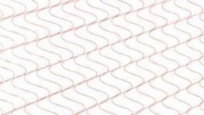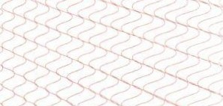TeXH11tteCKoro pernaMeHTa TaMolKettttoro COW3a TP TC 018/2011 "O 6eJOnacuocTu KonecHblX TPaHcnopTHblX cpeJICTB"

CEPTH<l>UKAT Bhl)lAH HA OCHOBAHHU npoToKona cepniqrnxauHO HHhlX HCnbITaHHH '.Nil 211220 -001-06/K OT 24.12.2021 ro.na, ! I BbJAaHuoro HcnblTaTenbHOH na6opaTopue 06uteCTea c orpaHutteTIHOH OTBeTCTBeHHOCTb lO «UeHTp HCCne.noeaHHH H HCnhlT311UH», arreCTaT aKKpe.n11TauH11 KG417/KUA.11JI.I49
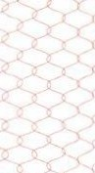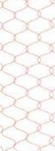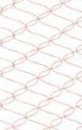CxeMa ceprnqmKau11w 1 1c

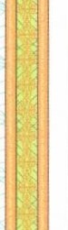I 1

)1.0nOJlHHTEJl bHASI 11H<l>OPMAU.1Ul f OCT 23544-84 <UKryTbl npoeo,!\OB JIJJJI aeTOTJ>aKTopuoro :me1<Tpoo6opy)loeam1J1 . 06m11e TCXHH'lCCKHe ycnOBHJI ». YcnoeWI H cpo101 xpaHeHHll npo11.yKUHH, cpoK CJJYJK6b1 (rOJ.tllOCTH) YKa:la Hbl B np11naraeMOH K npOIJ.YKUHH 3KcnnyaT3UHOHHOH )lOKyMel!T3UHH.

PyxoBOAHTenb (ynonttOM0•1ettttoe mmo) opraHa no ceprncjmKaUHH
3KcnepT (3KCnepT-ayAHTOp) (3KCnepTbl (3KcnepTbl-3YIJ.HTOpb!))
AU1eynoe AneKceii AneK ceeeH'I
(<1>110 )

A<t>11J1Tottoea ApHHa Pa.ztaMecoetta
(<!>HO)

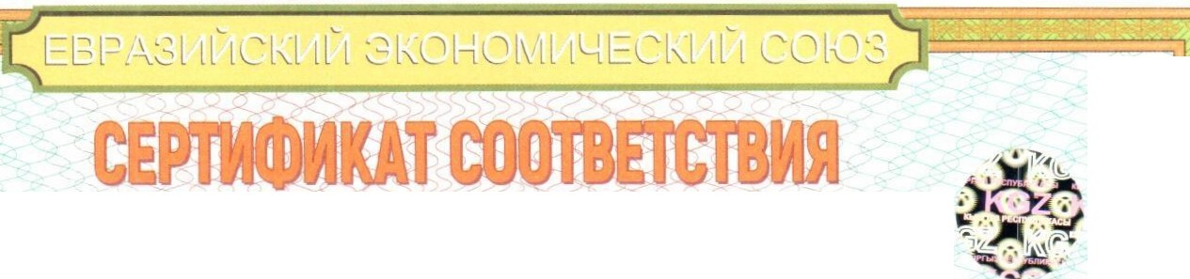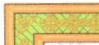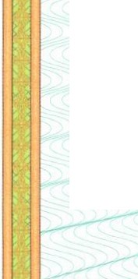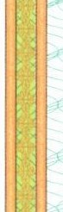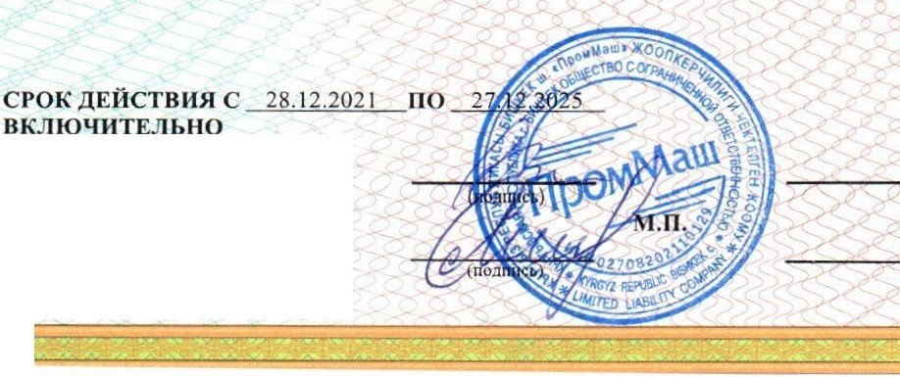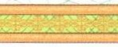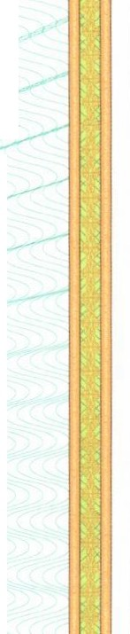
J

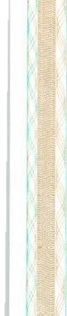

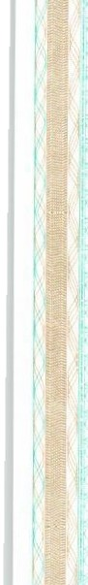

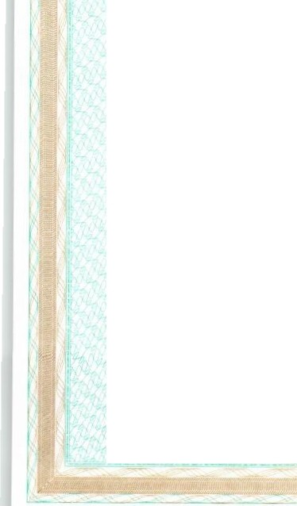PyKOBOllHTenb (ynonHOMO'!eHHOe
n11uo) opratta no ceprmjJ11Kau11H
3KcnepT (3KCnepT-ay,!lHTOp) (3KcnepTbJ (3KcnepTb1-ay.111nopb1))



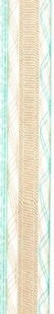

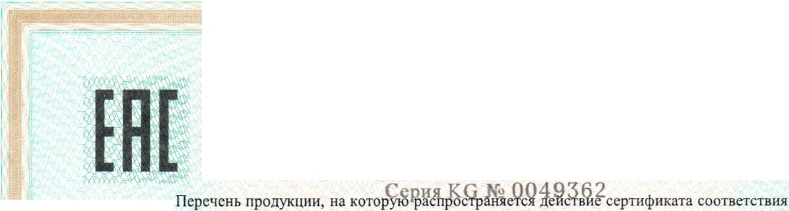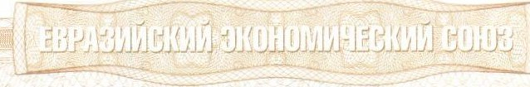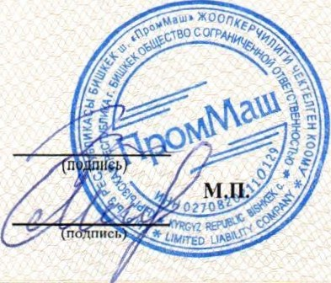11110 1 r03HAK2021r

IIPHJIOJKEHHE
K CEPTH<l>HKATY COOTBETCTBIDI
.N2' EA3C KG 417/KIJ,A .040.RU.02.00120

Ailleynoe Anexceij MeKceeBH'I
(<l>IIO)

Acj>11J1TOHOBa Apm1a Pa.uatecosHa
(<l>HO)
Ko.u (KO.Ub )  TH B3)J. TC | Ha11MeHOBam1e,THilbl, MapKH,MO,llem1npo}J.yKUH11, COCTaBHble tJ:aCTH H3J(emu1 HJIH KOMITJieKca
8544 30 000 7 | )!(ryrbl npOBO.llOB, aprnKynb1: Il8.D.OOl -3, IlBD.004-01 n, nBD.004-02 , nBD.004-03, OB.D,004-043, fIBD,004-047, Il8.lJ.005-02, nB.D.004-03 , n8,D.005-04, Il8,D.005-04E, IT8.ll006-02, n8,D.006-04, n8,D.006-06, Il8.[l007-02, n B.[1008  -o1o, n8.ll008-02, n8noos-o4, nsnoos-04E, nsno 10-03, nsno 10-05, rra11021-04, nB.D.099 , nBJl099-02, Il8D.l l l l, Il8112l 3-03, Il8,D.2 I 3-04, KJI008-06M, KJIOOS- 10, KJIOOS- 102, KJIOOS- 1OEn,KJIOOS-1OM, KJI008- l 6,  KJ1008-16M, KJIO 11-10, KJIO 11-1OEM, KJIO 11-1OEO,KJIO 11- 16, KJ1020-06 , KJ1020-102 , KJ1020- l OEM, KJ1020- l OEn, KJ1020-I on, KJ1022-06, KJ1022 - 1OEM, KJ1022-1OEn, KJ1023-1 OEM , KJ1023-1 OEn, KJ1033-I OEM, KJ1033-1 OEn, KJ1034-l OEM , KJI034- l OEn, KJI034-l OM,KJI035-06, KJI035-l OEM , KJ1035- l OEn, KJI035- l on, KJI037- l OEM,KJI037  - 1OEn, KJil 22-2KnH, KJ1038-l 0, KJI038-l 6, KJI038- I 6EM, KJI038-16En, KJI039-l 6, KJI039-l 6n, KJI043-l 6,  KJI046-25En , KJ1047-I OEM , KJ1047-1 OEn, KJ1047-16M , KJ1047-16n , KJI076- 16EM, KJI076-16En , KJI077 - 101,  KJl143-35EM, KJl 143-35En, KJl 144-25En, KJl I 45-l 6EM, Kii 145-l 6En, KJl I 63-25EM, KJlI 63-35En, Kii 186-25,  KJ1186-25n, KJ1186-53, KJ1040-16Il, KJI041-16, KJI041-16En , KJI041 - 16M, KJI041-.u., KJ1150-2SEM, KJIISJ -25EM, KJll51-25Eil, IlB.D.230-B, IIB.ll220, IlB,D.22 1-P,KTOOI , KT0 13, KTOl 7, KT020, KT045, KT045-2 , KT046, KT055, KT060, KT061 , KT061-1 KJI, KT062, KT062- l, nB614, IlB614-2n, I1B614-JI, I1B615, IT8615-11, nB615-JI,  ITB6 l 5-Jll1, n B6 l 7, nB618, IlB6 l 8-JI, 08620, 08620-11, Il8620-JI, nB62 l-JI, 08623-JI, Il8624-Jl, 08625-Jl, ITB625-Jl , I1B626, 08626-Jl, I1B627, I1B628, KJ1079-25EM, KJI079-25Eil, KJI080-1HKM, KJI080-1HHM , KJIOS0- 1YYM, KJ1080-2HKM,KJl080-2HKIT,KJJ080-2HHM, KJI080-2HHO , KJJ080-4HKM , KJJ080-4HKn , KJJ080-4HHM , KJT081-l KY, KJ1081 -l KYM, KJIOS l- 1KYO, KJIOSl -1HK, KJI08 1-l HKM, KJI081-IHKO,KJI08 l- 1HKIT, KJ1081-1HH, KJJ081-1YY, KJJOS 1-1YYM, KJJ081-2HJ< , KJJ08 l-2HKM, KJI081-2HKO, KJI081-2HH, KJI081-2HHM , KJl081-2HHn, KJ1081-4HKn , KI108 l -4HHn, KJJ096-l ,KII097-En , KJJl 16, KJil 39, KJl 142-4, KJil 42-5, KJil 43-25EM, KJI l 43-  25EO, KJl144-16EM, KJJ 144-16En, KJI200-HK , KJJ200-HH , KJ1203, KJ1238 , KJJ238-l, KJl240, KJI021-6, KJ112 l-  I K15, KJll2 1-1K20, KJll21- 1K25, KJI121-I K35, KJ1121 - I K40, KJil21 -1K45, KJl12 1-1K70, KJJ121-1 KK, KJII 21-l KKE, KJJ l 21-IHK , KJJ L2 l -IHH, KJ1121-l YY, KJIJ 21-2K20,KJ1121·2K25 , KJI12 1·2K35 , KJll 2 l-2K 70, KJJ 121-2KK, KJil2 l- 2KKE, KJI12 l-2HH, KJll2 1-3KK, KJl12 l-50KK , KJll 21-SOKKE, KJl12 l -50HH, KJl122-1KK, KJil22-I HH, KJll22-  I YY, KJI l 22-2KK, KJI I 22-2KKE, KJll22-2KH, KJ1122-2KH, KJJ I 22-2HH, KJJ I 22-3KK, KJJI 22-3KH, KJl122-3HH, KJJI 22-4KK, KJI I 22-4KKE, KJll 22-4HH, KJJI 22-5KK, KJJI 22-5HH, KJJI 22-6HH, KJJI 22-7HH, KJJI 22-KMH,  KJll22-KnH, KJJ l52, KJJl54, KJI154-KM H, KJll 92-HH, ITBO 15, 08015-1, I1BOl5-2, I1BOl6, nBO 16- 1, ns 103-1000, I1B 103-200,DB I 03-250, I1B I 03-300,IlBI 03-350,I1B I 03-400, ITB I 03-500, I1B I 03-600,I1BI 03-700, I1B I 03-800,  OB 103-900, nB 103-A11, I1B 103H- I 000, I1B IOJH-1200, ns 103H-I 400, nB I 03H- l 800,I1B 103H-200, I1B 103!-l-2300, nB 1031-l-2400, ITBl 031-1-250, I1B 103H-300, I1B 103H-3000, I1B 1OJH-350, ns 1031-l-400, ns103H-450, na I 03H-500, n8 I 03H-550, ITB I 03H-600, nB 103H-650, ITB I 0311-700,n B 103H-800, nB 103H-900, nsI 03Y-200, nB I 03Y-250, Il8103Y-300 , nB 103Y-350, n8103Y-400, OB 103Y-600, ns 103Y-650, IlB 103Y-650H,ITB 103Y-900, Il8288-16, ITB289- l 6, IlB290- l , ITB290-16, ITB290-3 , 08291-1, CTB291-l 6, 08291-25, KJJ00.1-1 6, KJIOOl-1 M, KJI006-l , KJI032, KJJ044-l, KJJ044-1M, KJJ044-I n, KJI049- l , KJIOS0-1, KJl05 l -l , KJI05 l- l KAMP, KJJ052-l, KJ1054 - l 01,  KJ1054-l08 , KJ1056- 18, KJI056-lf, KJI057-I ,KJI058,KJI059, KJl06 1, KJI064-l, KJ1064-IM, KJ1065-1,KJI065-1M, KJI065- III, KJ1066- 1, KJI066-I M, KJI066- l MP, KJI066- Ln, KJl067 - 1, KJI067- l M, KJI067- Ln, KJ1082- 1, KJ1082-K, KJJI 15, KJll 23, KJJI 24, KJII 25-1, KJII 26-1, KJI126-Y.u.,Kii 127, KJJ 129- 1, KJJI 29-2, KJll 29-Y,D., KJl 130, KJJI 31, KJJl64-1, KJll65-I, KJI166-1, KJJl67-I , KJll76-1, KJJ187- l , KJJl88-l, KJil88-2 , KJl203-1 , KJJ204-1 Y, KJJ205-I Y,  KJI206- IY,KJ1207-1, KJI208-1, KJl230 , KJI231, KJl232 , KJD1003, KJll1004 , KJll1005, KJ111007-W, KJll1016, KJll1025- M, KJl11025-n, KJU1034, KJII104 I , KJTl1067, KJl11104-B, IlB098, IT8098-5/700,08002, 08003-1, I1B003-2, OB126- 8, ITB 126-82, ITB 126-83, nB 126-P, ITB126-P2, I1B 127-B, nB 127-P, nB273, IlB273-B, ITB273-8 I , nB273-K, rTB273- Kl , 08273-0, I1B273-nJ , ITB274, IT8274-l, ITB275, ITB276, nB277, fl8283, I1B285,ITB285-l, IIB286, nB286-l ,  ITB286-2, ITB287, ITB34 l.

